Posted on blog 4/5/17
Shared on FB, Twitter, and Linkedin update
Revised for list 4/8/17, personal FB page and following week Linkedin Article.

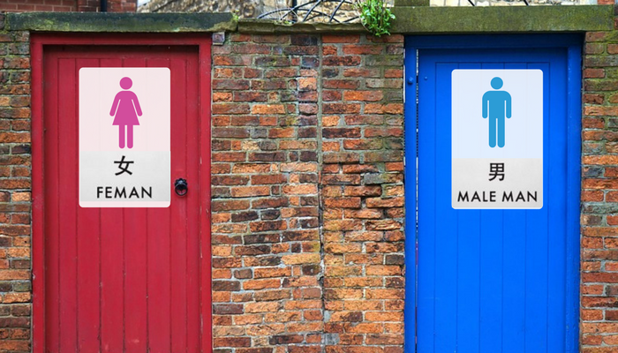

Do Your Words Speak Your Brand?
Or Are They A Turnoff…

I traveled a lot internationally during the first 17 years of my career. Some countries I went to had cultural differences that seemed charming.

While others were so different they seemed more, well… foreign.

To me, that’s how many Asian countries felt. Foreign.

One of my colleagues thought it was because we were 2 businesswomen in a male-dominant culture.

That may have been part of it.

And yes it’s true… some things simply do get lost in translation. I experienced that firsthand during one trip to Seoul, Korea when I was working with Nickelodeon.

As with most Asian cultures, Koreans are very service oriented. This is particularly true in a hotel like The Shilla, which caters to business travelers.

The Shilla staff always went out of their way to please their guests. And they did so oozing with formality and politeness.

Everything I experienced at The Shilla communicated a clear message. “We appreciate you. We will take good care of you. We’ll treat you like royalty.”

That’s what made this one tiny, 3-letter word so grating when I heard it. Here’s what happened.

The morning after I arrived, I stepped into an empty elevator to go downstairs for a meeting.

On the ground floor, one woman’s job was to wait for the doors to open and to greet the elevator passengers.

The doors to my elevator opened. And there she was with a big smile on her face. She gave me a cheery and enthusiastic, “Good morning, sir!”

I paused, a little perplexed. Maybe I’m so jet lagged I didn’t notice there was someone else in the elevator with me…?

I looked over both shoulders.

Nope. No one but me.

I smiled back and said, “Good morning” as I walked out of the elevator.

That was weird, I thought. I mean, come on. I have long red hair and was wearing lipstick and pumps.

Later that day I phoned for room service. After giving my order the woman asked, “Anything else, sir?”

Pause.

“Ah, no. Thank you.”

When a different cheery elevator greeter “sir-ed” me again the next morning, I knew something was up. These weren’t flukes.

Later that day I met with my representative, a Korean woman who had been living in the US for years. I told her about my experience and she explained that the Korean language is gender neutral. There’s no “he” or “she.”

And Koreans aren’t accustomed to women executives. So when they’re taught English to interact with business people, they only learn how to address men.

Over the course of my stay in Seoul, I was called “sir” quite often. And it jarred me for a moment each time it happened.

The Shilla expressed their brand message of style, comfort, elegance and service in so many tiny details throughout my stay. And addressing me with politeness and respect would have been another… But by calling me “sir,” they bombed.

Big time.

Now as a marketer, you would never do something to disconnect your brand from your customers or make them feel misunderstood, right?

But maybe you are, without even realizing it. Just like the hotel staff at The Shilla. And if you do…

You’re missing an opportunity
to make a positive emotional connection with your customers

Not only that. You could even be alienating them.

So what should you do?

You need to get clear on your brand message. And you need to make sure it’s relevant to your ideal customer. It needs to connect with them on an emotional level.

Every customer interaction is an opportunity to strengthen that connection. So you need to ensure all your marketing material and your copy reflects your brand.

This is where working with a skilled copywriter makes all the difference. And it’s important to make sure your copywriter understands your brand’s emotional identity before they start writing.

If you haven’t done so already, take the time to think through and document your brand’s values, personality and voice. It will go a long way in ensuring you consistently communicate a customer-relevant brand message.

About the author: I am a global brand strategist and loyalty marketer turned copywriter. I write copy for natural health, wellness, and beauty companies. And I help business owners understand and clarify their brand. Before launching Piper Marketing Solutions, I built multi-million dollar businesses for MTV, Nickelodeon, The Sharper Image, and Pokémon. Want help getting clear about your brand? Grab my eBook, Brand Magnetism – 3 simple steps to attracting customers… and keep them coming back for more. It’s FREE.

